**League of Nations.**

Introduction.

The allies set up the League of Nations to preserve world peace and to stop future wars after the destruction caused in World War One. It was the USA’s idea and the creation of it was one of Woodrow Wilson’s fourteen points. It was set up to resolve disputes and conflicts between countries. The League of Nations required all countries to join or it would not be a success. The USA, however, refused to join. This was not good because the USA was the most powerful country and Wilson, the US President at the end of World War One, invented it, so that possibly contributed to the League failing in the end.

*Isabell Long*

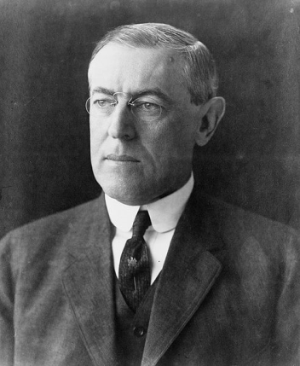 

Woodrow Wilson League of Nations logo